وزارة التعليم العالي والبحث العلمي
 | 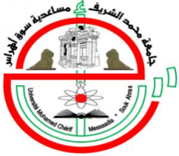 | جامعـة محمد الشريف مساعدية - سوق أهراس  Mohamed Cherif Messadia University - Souk-Ahras
Faculty of Life and Nature Sciences
Department of Biology

MEMORY

Presented in view of obtaining the Master's degree

intitulé

Field

…………………………
Specialty

………………………….

By

Name | and | Name

Jury
President : | Name | Grade | U. Souk-Ahras
Supervisor : | Name | Grade | U. Souk-Ahras
Examiner : | Name | Grade | U. Souk-Ahras

